** **

**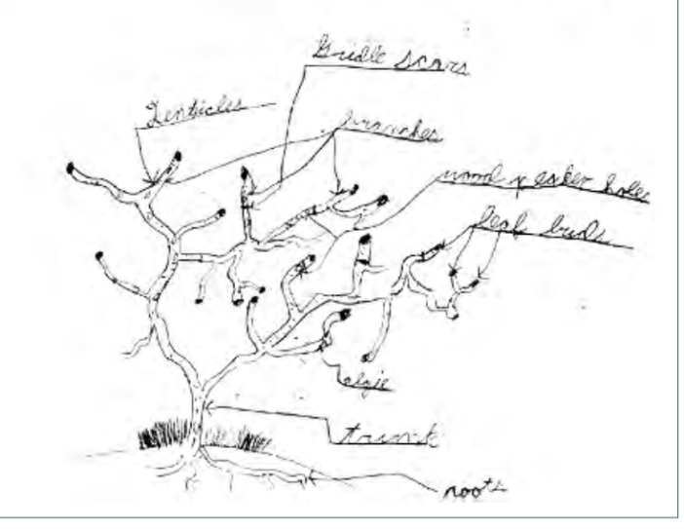**

**Trees as Habitats**

PLTK-8 guide #22

**Tree Benefits**

**Trees as Habitat #22  **

**Tree Number\_\_\_\_\_\_\_\_\_\_**

**Descriptive Question:  *Do trees provide habitat for a diversity of organisms?***

1. What do you find on the tree’s trunk?
2. What do you see in the tree’s branches?
3. What do you see on the tree’s leaves?
4. What evidence do you see or hear that indicates animals use the tree?
5. What evidence do you see that other plants are using the tree as a habitat?
6. How many different types (species) of organisms (plants, animals, fungi) did you find?\_\_\_\_\_\_\_\_\_\_
7. How many different types (species) of organisms did you find evidence for?\_\_\_\_\_\_\_\_
8. Add 6 and 7 together and record for your tree on the graph\_\_\_\_\_\_\_\_\_\_\_.

**Graph of the Numbers of Different Types of Organisms Found or Evidence of and the Tree Observed**

|  |  |  |  |  |  |  |  |  |  |  |
| --- | --- | --- | --- | --- | --- | --- | --- | --- | --- | --- |
| 20 |  |  |  |  |  |  |  |  |  |  |
| 19 |  |  |  |  |  |  |  |  |  |  |
| 18 |  |  |  |  |  |  |  |  |  |  |
| 17 |  |  |  |  |  |  |  |  |  |  |
| 16 |  |  |  |  |  |  |  |  |  |  |
| 15 |  |  |  |  |  |  |  |  |  |  |
| 14 |  |  |  |  |  |  |  |  |  |  |
| 13 |  |  |  |  |  |  |  |  |  |  |
| 12 |  |  |  |  |  |  |  |  |  |  |
| 11 |  |  |  |  |  |  |  |  |  |  |
| 10 |  |  |  |  |  |  |  |  |  |  |
| 9 |  |  |  |  |  |  |  |  |  |  |
| 8 |  |  |  |  |  |  |  |  |  |  |
| 7 |  |  |  |  |  |  |  |  |  |  |
| 6 |  |  |  |  |  |  |  |  |  |  |
| 5 |  |  |  |  |  |  |  |  |  |  |
| 4 |  |  |  |  |  |  |  |  |  |  |
| 3 |  |  |  |  |  |  |  |  |  |  |
| 2 |  |  |  |  |  |  |  |  |  |  |
| 1 |  |  |  |  |  |  |  |  |  |  |
|  | Tree 1  na02407_ | Tree 2  na02407_ | Tree 3  na02407_ | Tree 4  na02407_ | Tree 5  na02407_ | Tree 6  na02407_ | Tree 7  na02407_ | Tree 8  na02407_ | Tree 9  na02407_ | Tree 10  na02407_ |

Number of Different Types of Organisms Found

*Categorize the organisms and evidence of organisms you found.*

|  |  |
| --- | --- |
| **Category-Plants (other than mosses and lichens)** | **Category-Animals** |
|  |  |
| **Category- Fungi** | **Category- Moss and Lichens** |
|  |  |

**Claim, Evidence, Reasoning**

Write a scientific explanation that answers the question:

***Do trees provide habitat for a diversity of organisms?***

|  |
| --- |
| **Claim** |
| **Evidence** |
| **Reasoning** |

**Benefits of Trees as Part of an Ecosystem** [www.treebenefits.com](http://www.treebenefits.com)

Name of Tree\_\_\_\_\_\_\_\_\_\_\_\_\_\_\_\_\_\_\_\_\_\_\_\_\_\_\_\_\_\_\_\_\_\_\_\_\_\_\_\_\_\_\_\_

Circumference (C) \_\_\_\_\_\_\_\_\_\_\_\_\_**inches**

To calculate diameter:

Circumference **÷** π(3.14) = \_\_\_\_\_\_\_\_\_\_\_\_Diameter (do not record numbers after the decimal)

**STORMWATER**

How many gallons of runoff will your tree stop this year?\_\_\_\_\_\_\_\_\_\_\_

*Look at the bullet points to answer this next set of questions.*

Trees reduce run-off by:

●Intercepting and \_\_\_\_\_\_\_\_\_\_\_\_rain on leaves, branches and bark

●Increasing infiltration and storage of rainwater through the \_\_\_\_\_\_\_\_\_\_\_\_\_\_\_\_\_

●Reducing soil \_\_\_\_\_\_\_\_\_\_\_\_\_\_\_by slowing rainfall before it strikes the soil

**CO2**

1) Your tree will reduce carbon in the atmosphere by \_\_\_\_\_\_\_\_\_\_\_\_\_\_\_ pounds this year.

2) An “average” car generates \_\_\_\_\_\_\_\_\_\_\_\_\_\_\_\_\_\_ pounds of CO2 every year.

3) In the first bullet point we learn that trees reduce carbon in the atmosphere because they

lock up \_\_\_\_\_\_\_\_\_\_\_\_ in their\_\_\_\_\_\_\_\_\_\_\_\_\_\_\_\_\_\_\_\_\_\_\_\_\_\_\_\_\_\_\_\_\_\_\_\_\_\_\_\_\_\_\_\_\_\_\_\_\_\_

while they grow and in wood products after they are harvested.

**Total Stormwater Runoff intercepted by trees on campus**

|  |  |  |  |
| --- | --- | --- | --- |
| **Tree** | **Circumference** | **Diameter** | **Water intercepted**  **(Gallons )** |
|  |  |  |  |
|  |  |  |  |
|  |  |  |  |
|  |  |  |  |
|  |  |  |  |
|  |  |  |  |
|  |  |  |  |
|  |  |  |  |
|  |  |  |  |
|  |  |  |  |
|  |  |  |  |
|  |  |  |  |
|  |  |  |  |
|  |  |  |  |
|  |  |  |  |
|  |  |  |  |
|  |  |  |  |
|  |  |  |  |
|  |  |  |  |
| Total Water Intercepted on Campus | | |  |