Tree Cookies PLT #76
Tree Factory #63

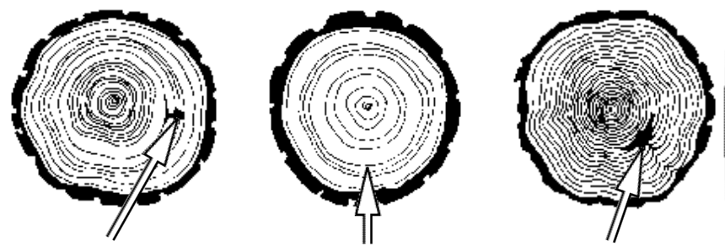

Going from observation to comparison and from descriptive to comparative field study investigations

Name_______________________________
Tree as a System
Draw and label the parts a tree

Identify the Parts of the Tree and their Function

Part | Function

Looking for Patterns on Tree Cookies

- Descriptive Question: What are some of the patterns found on the tree cookie?

- How is your tree cookie similar to your neighbor’s?

- How is your tree cookie different than your neighbor’s?

Tree Biology
From PLT pre-K to 8 Guide student page https://www.plt.org/stuff/contentmgr/files/1/ab5a339c2da123e944f8518639c0adb5/files/activity_76_student_pages.pdf

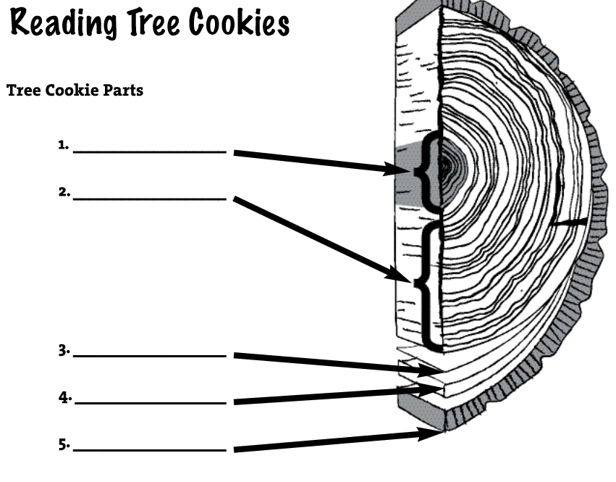

The Parts of the Tree and Function

Part | Function
Heartwood
Xylem (sapwood)
Cambium
Phloem
Bark
- How old was your tree when it was cut?

- What factors could be a cause for the differences in ring size on your tree cookie?

- What factors could be a cause for the differences you observed between your tree and your neighbor’s tree?

4-LS1-1. | Construct an argument that plants and animals have internal and external structures that function to support survival, growth, behavior, and reproduction. [Clarification Statement: Examples of structures could include thorns, stems, roots, colored petals, heart, stomach, lung, brain, and skin.] [Assessment Boundary: Assessment is limited to macroscopic structures within plant and animal systems.]

Tree Investigation

Compare your tree to 2 other trees.
Comparative field study investigation: Which tree grew larger in the first 10 years of its life?

Procedure:

Tree | Measurement
Claim

Evidence

Reasoning

How might you answer the question” Which tree grew fastest in the first 10 years of its life?” in the field? How would you reword the question?

Next Generation Science Standards-Cross Cutting Concepts

- Patterns. Observed patterns of forms and events guide organization and classification, and they prompt questions about relationships and the factors that influence them.
- Cause and effect: Mechanism and explanation. Events have causes, sometimes simple, sometimes multifaceted. A major activity of science is investigating and explaining causal relationships and the mechanisms by which they are mediated. Such mechanisms can then be tested across given contexts and used to predict and explain events in new contexts.
- Scale, proportion, and quantity. In considering phenomena, it is critical to recognize what is relevant at different measures of size, time, and energy and to recognize how changes in scale, proportion, or quantity affect a system’s structure or performance
- Systems and system models. Defining the system under study-specifying its boundaries and making explicit a model of that system-provides tools for understanding and testing ideas that are applicable throughout science and engineering.
- Energy and matter: Flows, cycles, and conservation. Tracking fluxes of energy and matter into, out of, and within systems helps one understand the system’s possibilities and limitations.
- Structure and function. The way in which an object or living thing is shaped and its substructure determine many of its properties and functions.
- Stability and change. For natural and built systems alike, conditions of stability and determinants of rates of change or evolution of a system are critical elements of study.

