FieldSTEM

Journal

by

_________________________

# C:\Users\tashley\AppData\Local\Microsoft\Windows\Temporary Internet Files\Content.IE5\I0ZS1CYR\MC900155671[1].wmf



**Project Learning Tree Lessons**

* Signs of Fall PLT #78
* Focus on Forests-Monitoring Forest Health #1
* Focus on Forests-Climate Change and Forests #8

**Signs of Fall #78 C:\Program Files (x86)\Microsoft Office\MEDIA\CAGCAT10\j0298897.wmf**

1. What signs do you see that winter is approaching?
2. Find the tree with the brightest yellow leaves, deepest red, darkest green.
3. How do leaves change after they fall?
4. Observe a deciduous tree that has changed color. Look for patterns. Is it all the same color? Where are the colors the brightest?
5. Look at a leaf that has turned color. Is it all one color? Is there a pattern to the color in the leaf? Match the leaf color to a paint chip.
6. From where you are standing, count or tally all the trees you see that are deciduous and that are evergreen.

**Comparative Question:** Are deciduous trees or evergreen trees more abundant in the Rainbow Lodge Forest?

|  |  |
| --- | --- |
| # Evergreen Trees | # Deciduous Trees |
|  |  |

1. Read or listen to an article on how leaves change color. What are the pigments the article mentions?

**__________________________________________________________________________________**

1. Take a minute to share out with a neighbor how leaves change color.
2. What cross cutting concepts did we use?
3. What practices of Science and Engineering did we participate in?

**Signs of Fall-Invisible Changes**

**Descriptive Question:** What colored pigments are in green leaves?

1. Tear up 2 green leaves into tiny pieces and place in jar.
2. Add enough alcohol to cover the pieces.
3. Leave overnight.
4. Tape the end of a filter strip to a pencil.
5. Adjust strip so the end just touches the alcohol
6. Wait 1-2 hours and observe

What colors do you see on the filter strip? Draw the strip here:

If you did this experiment comparing green leaves to yellow leaves what would your comparative question be?

For the comparative investigation what things would you need to keep the same (controlled variables)?

**See the article for Correlative investigation**

**Next Generation Science Standards Framework**

**Main Cross Cutting Concepts**

**Main Practices of Science and Engineering**

* [www.budburst.org](http://www.budburst.org) for leaf fall
* Book-*Why Do Leaves Change Color?* By Betsy Maestro
* Book-*How Leaves Change* by Silvia Johnson

**Focus on Forests: Lesson 1 Monitoring Forest Health-Part B-Ecosystem Services**

**Type of Tree Abundance**

**Data Collection Sheet**

**Comparative Question:** Which type of tree is most abundant in the Forest atRainbow Lodge**?**

**Prediction:_________________________________________________________________________**

**Materials:__________________________________________________________________________**

Forest Name:

Canopy closure %:

Location:

Date:

Type of Forest (Deciduous, conifer, mixed):

Length of transect Line:

**Descriptive Question:** How much water do trees in the forest at Rainbow Lodge intercept?

|  |  |
| --- | --- |
|  |  |
|  | |

## Type of Tree Abundance Data Collection Sheet

Transect (Trail) number:_______

|  |  |  |  |  |
| --- | --- | --- | --- | --- |
| **#** | **Type of Tree** | **Circumference (at 4.5 ft high)** | **Diameter**  **Circumference**  𝛑 | **Water Intercepted -gallons** |
| 1 |  |  |  |  |
| 2 |  |  |  |  |
| 3 |  |  |  |  |
| 4 |  |  | **Combine data from 4 groups** |  |
| 5 |  |  |  |  |
| 6 |  |  |  |  |
| 7 |  |  |  |  |
| 8 |  |  |  |  |
| 9 |  |  |  |  |
| 10 |  |  |  |  |
| 11 |  |  |  |  |
| 12 |  |  |  |  |
| 13 |  |  |  |  |
| 14 |  |  |  |  |
| 15 |  |  |  |  |
| 16 |  |  |  |  |
| 17 |  |  |  |  |
| 18 |  |  |  |  |
| 19 |  |  |  |  |
| 20 | Total water Intercepted | | |  |

## Creating Circle Plots

**Materials:** Per study plot: 4 ropes or measuring tapes and 12 flags

**Procedure:**

1. Students are in groups of 8.
2. Four students find the stake that marks the center of their study plot. They face out putting their backs together. Each holds one end of a 37.2 feet rope or measuring tape (four ropes total).
3. Each of the four other students takes the other of end of one of a ropes and walks away from the center until the rope ends. They each place a flag at this spot. ( represented by the black flag in the diagram)
4. Now the students at the outside of the circle either go back to the center and walk outward again with the rope in a different direction 2 more times, flagging the 2 new spots (represented by the white flags). Or students can leave the rope where it is and just estimate 2 more flags between them and the rope line to their right.
5. The flags mark the outer boundary of the circle plot that is **1/10 of an acre.** Leaving the ropes on the ground allow pairs of students to know their ¼ section of the plot where they are to identify and measure circumference of trees and record in the data table.

37.2 ft

**Question: Which type of tree (**Douglas-fir, Hemlock, Red Cedar, Big Leaf Maple, Alder, or Vine Maple) **is most abundant in the Forest at Rainbow Lodge?**

**Combine data from 4 study plots**

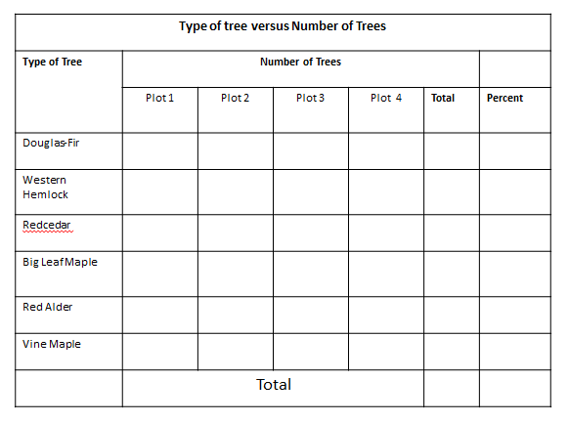

**Question: Which type of tree is most abundant in the Forest at Rainbow Lodge?**

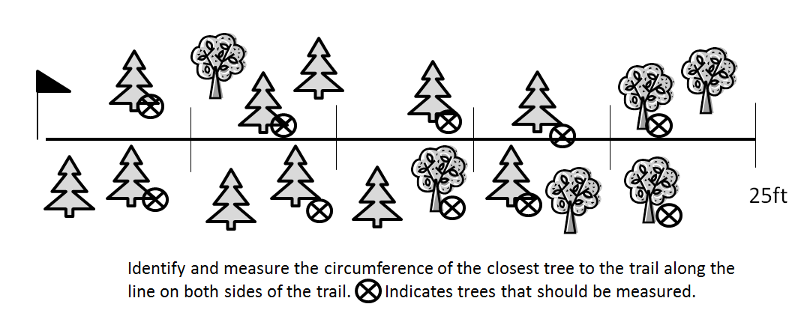

**Transect procedure**

1. Look at the forest predict which type of tree will be most abundant (have the greatest number) in the forest.
2. Find your transect numbered flag along the trail.
3. Stretch your measuring tape **25 feet along** the trail.
4. Count the closest 10 trees (over 5” diameter) along both sides of the trail and determine if they are Douglas-fir, Hemlock, Redcedar, Vine maple, Alder, or Big Leaf Maple Trees and record.
5. Measure the circumference of each of the 10 trees at DBH and record in inches.
6. Each transect is a trial and record your information under your transect number on the data table.l

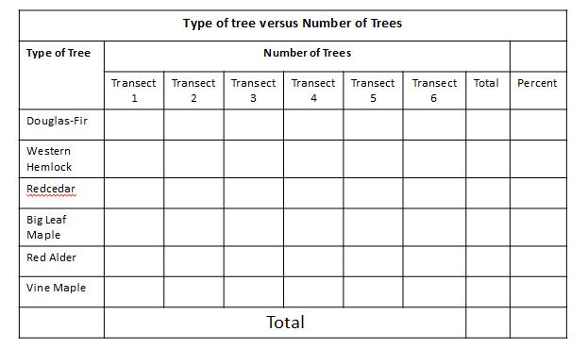

**Combine data from 6 transects**

**Draw a pie chart to share your information**

**Tree Abundance Conclusion**

Which type of tree is most abundant in the Forest at the Rainbow Lodge, North Bend, Washington?

* Limit conclusion to place, date, and time of investigation
* A conclusive statement clearly answers the investigation question Or answers the prediction
* Supporting data for lowest condition
* Supporting data for the highest condition or trend data
* Explanatory Language

[**www.treebenefits.com**](http://www.treebenefits.com)

How much water do the trees in the Rainbow Lodge Forest intercept in a year as estimated by Tree Benefits website?

|  |  |  |
| --- | --- | --- |
| **Transect/**  **Plot** | **Number Trees** | **Water Intercepted/year** |
| 1 |  |  |
| 2 |  |  |
| 3 |  |  |
| 4 |  |  |
| 5 |  |  |
| 6 |  |  |
| **Total** |  |  |

**If transects**-amount of water intercepted per year by trees sampled

**_____________________**

**If study plots-**Averagewater intercepted per acre of Rainbow Lodge Forest (if did 1/10 acre plots)

Total water intercepted ÷4 x10= water intercepted per acre

**_________________________________**

Read “Trees as Speed Bumps”. Using information from both the website and article, list ways in which trees benefit the watershed.

**Notes on how to take Tree Height**

**Focus on Forests: Lesson 8- Climate Change and Forests-Part B How Much Carbon can a Tree Hold?**

|  |  |  |
| --- | --- | --- |
| **Type of Tree:** | | |
|  | | |
| **Circumference meters** |  | |
| **Circumference inches** |  | |
|  | | |
| **Diameter meters** |  | |
| **Diameter inches** |  | |
|  | | |
| **Height of tree meters** | |  |
| **Height of tree feet** | |  |

**Carbon sequestered per year__________lbs.**

**(**[**www.treebenefits.com**](http://www.treebenefits.com)**)**

**Carbon stored in the Tree_________kg**

**(page 139 chart)**

**Carbon stored in the Tree_________lbs**

**( ____kg x 2.2=lbs)**

**Pacific Education Institute’s**

**Science Journal**



<http://www.pacificeducationinstitute.org/>



National PLT <http://www.plt.org/>

* Pat Otto [tootieotto@comcast.net](mailto:tootieotto@comcast.net)
* Julie Luthy [julieluthy@gmail.com](mailto:julieluthy@gmail.com)
* Breanna Trygg [BTrygg@pacificeducationinstitute.org](mailto:BTrygg@pacificeducationinstitute.org)

Tree Cards-<http://www.wnps.org/education/resources/plantid_cn.html>